**Tableau Parts 3 and 4: Exercises with answers**

Exercise 3

1. For these exercises, we will be using the ‘employee’ tables. Import the files **employee.csv** and **department.csv** into Tableau from your data directory.

Answer : Import the .csv files from the data folder with the Connect panel.

1. Perform a left join between employee.csv and department.csv. Click the join drawing and find out which column is used for this join.

Answer: Dept Id is the column used for this join.

1. Perform a full outer join between the employee and department tables. How many rows are returned by this join? (You can see the number of rows on the right corner of the bar below the joins.)

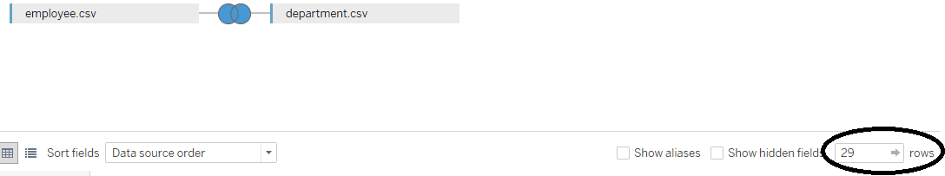

1. Now, import the project table, **project.csv**, into Tableau. Perform an inner join with the employee table. Perform an inner join on the employee and department tables, and then a left join on the employee and project tables.

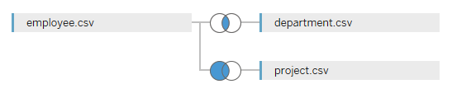

1. On a new sheet, plot a bar chart showing Total Employees for each Dept Name. Make sure that the Total Employee column is aggregated as an Attribute.

Answer:

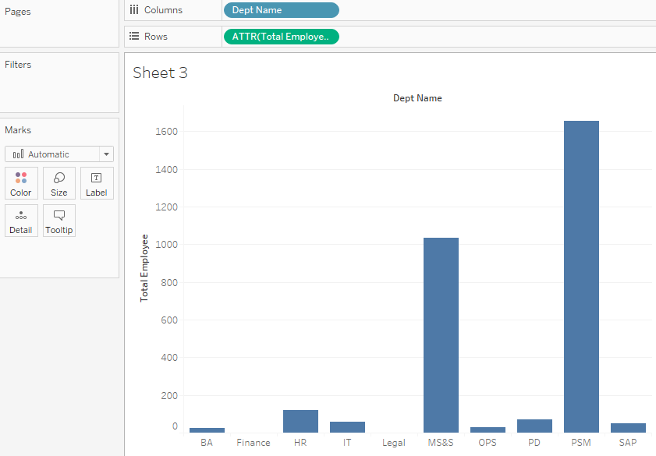

1. Sort the bars in descending order of the Total Employee column.

Which two departments have the largest number of employees?

Answer: PSM and MS&S have the largest number of employees by a large margin.

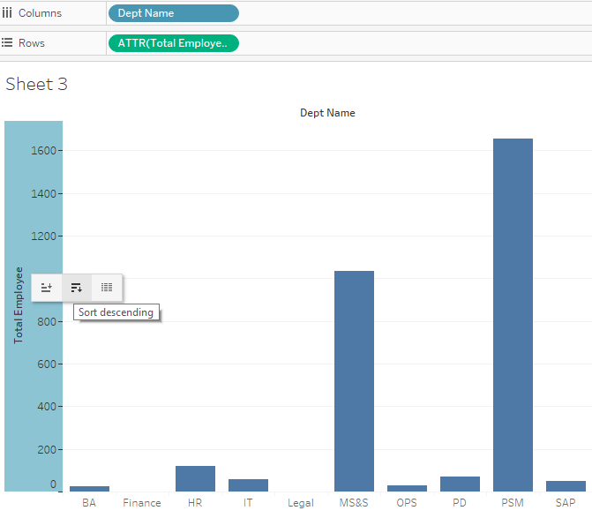

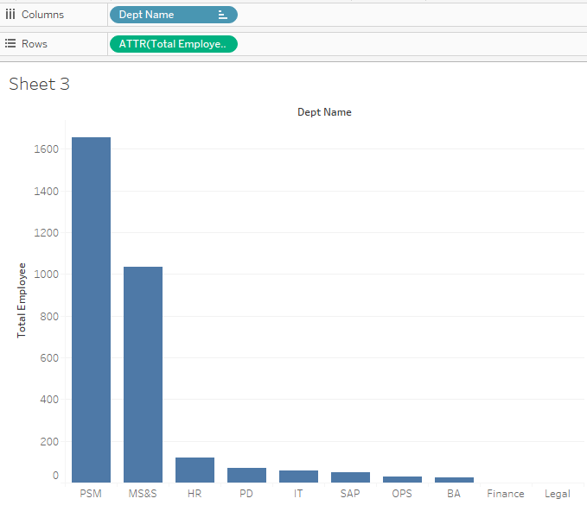

1. Now bin the Total Employee column using a bin size of 500, and color by Dept Name. How many bins do you see?

Answer: 4

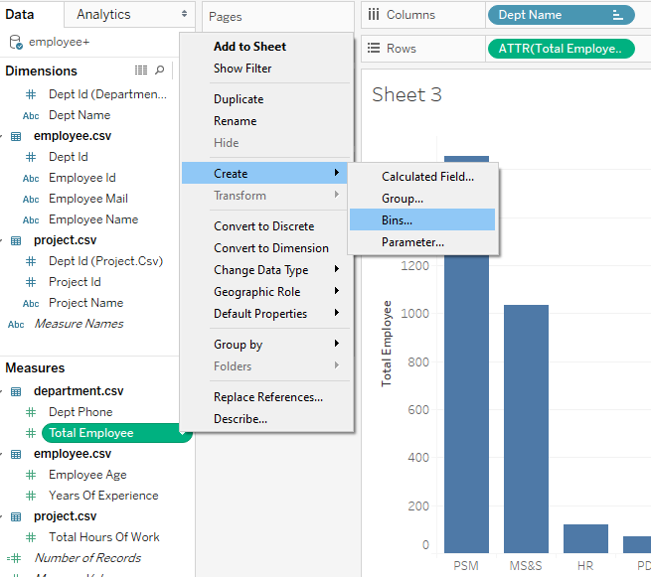

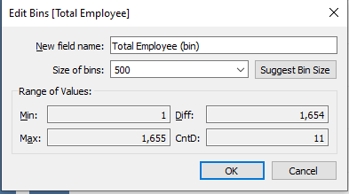

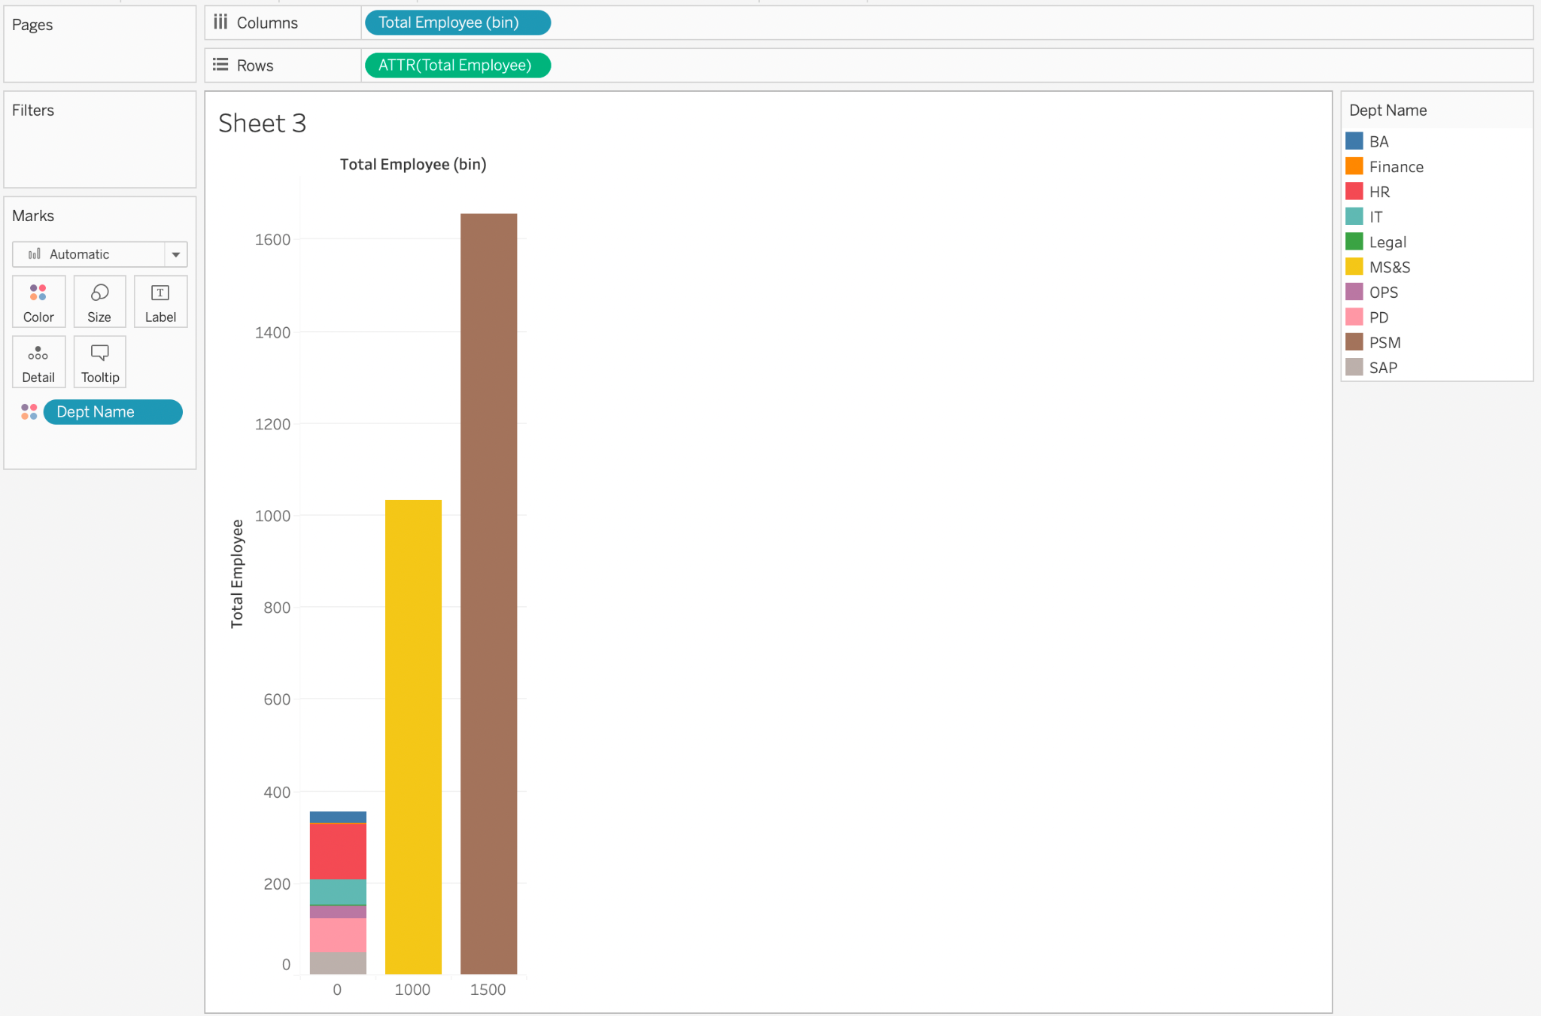

Exercise 4

1. On a new sheet, create a vertical bar chart to show average Years Of Experience for each Dept Name.

Answer:

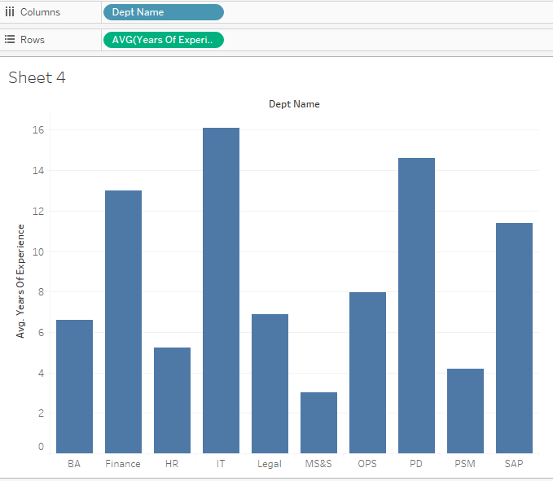

1. Add a filter to the above bar chart to only include Project Names BA101 and IT111.

Answer: Show filter by right-clicking on Project Name in the Filter shelf and selecting Show Filter. You will notice that the Project Name filter appears on the right side of the screen.

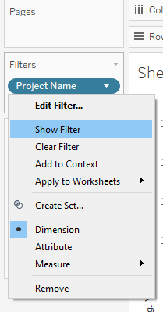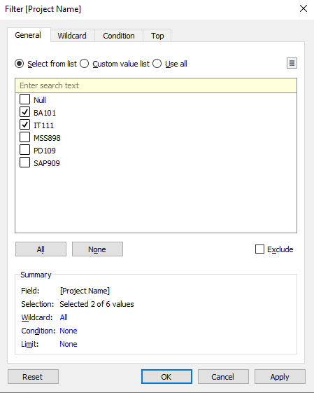

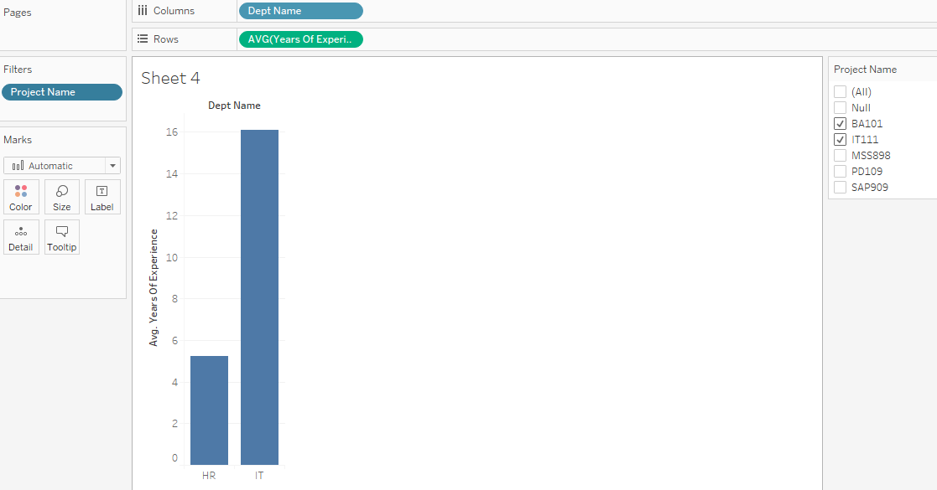

1. Answer the following questions by changing the filter options.
   1. What is the average Years Of Experience for an employee working on Project MSS898?

Answer: 3.033

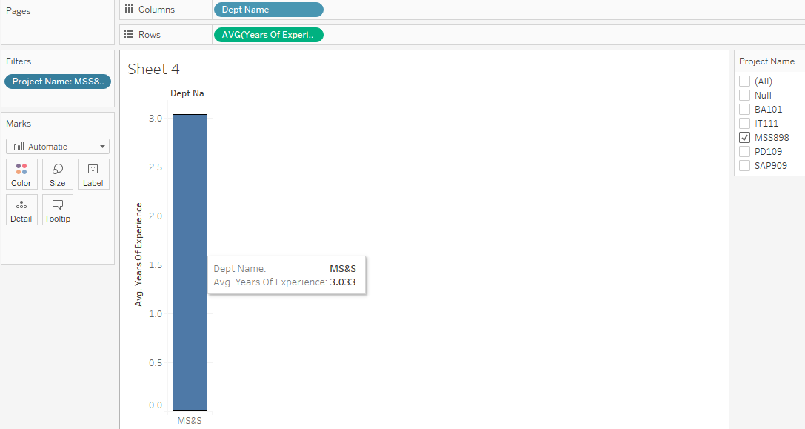

* 1. Out of Projects PD109 and SAP909, which project has employees with fewer Average Years Of Experience?

Answer: SAP909

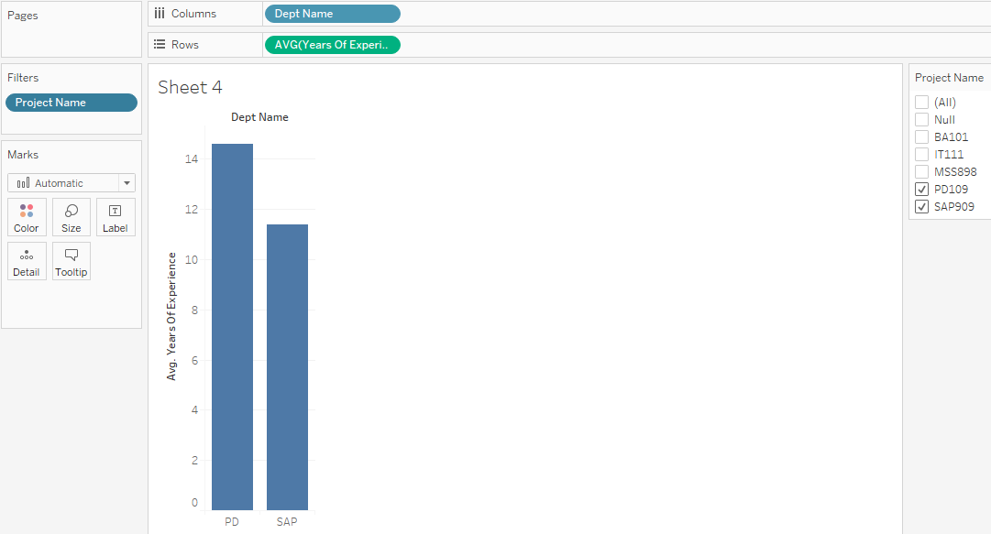

1. Now, add a filter for Average Employee Age to the chart. Which Dept Names have an average Employee Age between 30 and 40 years?

Answer: Finance and SAP departments have Average Employee Age between 35 and 45 years.

